MLS Production Process
MLS Tool: -
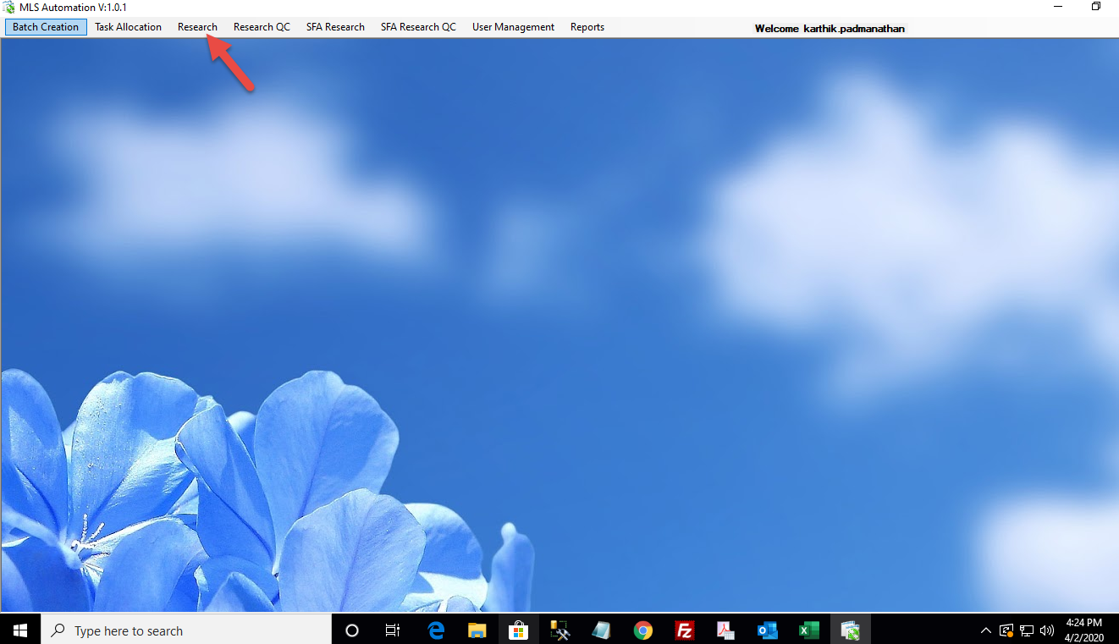

Click Research ->
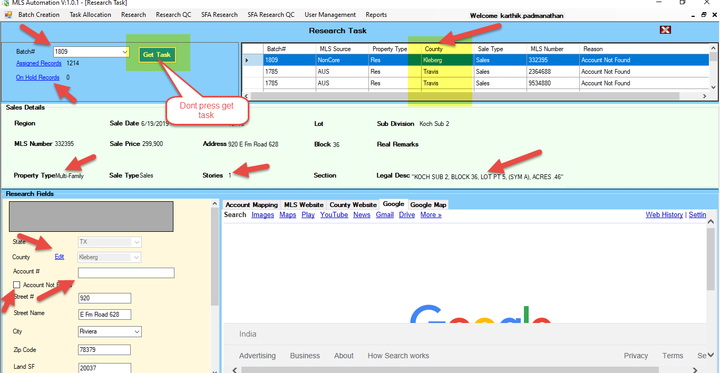

mlsChecking the below fields in production screen: -
County
County should be open as like Nasa (termserv or normal)
Address
Copy the address from MLS tool and find the account number in respective cad
Legal Description
Legal description and address should match with the MLS tool
Account Number finding
If all the above criteria match in the MLS tool VS CAD website, then copy the account and paste it in MLS tool account number fields
If given information does not match with cad, then we must check zip code to find the county and search the account in founded county then paste the account in MLS tool.
Even, if we cannot find the account just, we have an option in tool account number not found.
LUC update
Check with property type, style and stories to map the LUC in MLS tool or please match the information in cad to update the LUC code and complete the record.
If any doubt, please hold the record and the MLS team will clarify the records for further proceedings.
Hold Records
If the records are hold by the user, it will go under on hold records where you can see the pending counts.
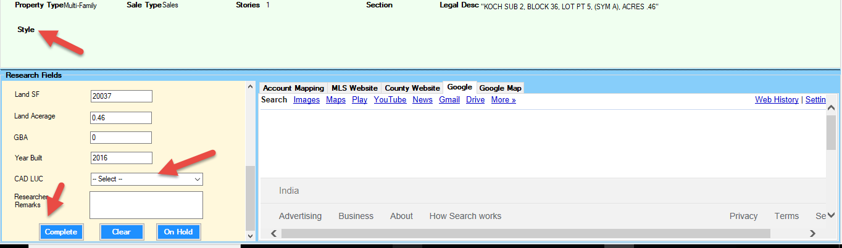

Complete
If you complete the records, it will automatically reduce from assigned count.

